**Making a Moderation Plot with SPSS**

The data here are from the Plot output from Process Hayes, for three continuous variables. Emot_Exhaust is the Y variable, Surface_Acting the X variable, and Psy_Cap the moderator variable.

data list free/Surface_Acting Psy_Cap Emot_Exhaust.

begin data.

-1.0000 -1.0000 -.2128

.0000 -1.0000 .2756

1.0000 -1.0000 .7640

-1.0000 .0000 -.4130

.0000 .0000 -.0252

1.0000 .0000 .3626

-1.0000 1.0000 -.6132

.0000 1.0000 -.3260

1.0000 1.0000 -.0388

end data.

graph/scatterplot=Surface_Acting with Emot_Exhaust by Psy_Cap.

* Open up the chart editor (double click on the plot)
* Click on a marker to select them all.
* Click on Elements, Interpolation Line.
* In the upper right hand corner, outside of the plot area, click on each of the markers and change the border and fill colors, size, and shape, as desired.
* Right-click in the body of the plot, select Properties Window, change Fill to white.
* Double click on a value on the X axis. Select the desired font, style, and size.
* Do the same for the Y axis.
* Double click on an axis label to edit it as desired.
* Double click on a line and change its weight/style/color, if desired.
* Save the chart as a jpg.
* Open the chart with a photo editor.
* Crop out the undesired text in the upper right hand corner and resize if desired.
* Save the modified plot.
* Bring the plot into a Word document and add a figure caption.
* Below the plot add a key identify the lines by level of the moderating variable.

Here is what the plot looked like before final editing:

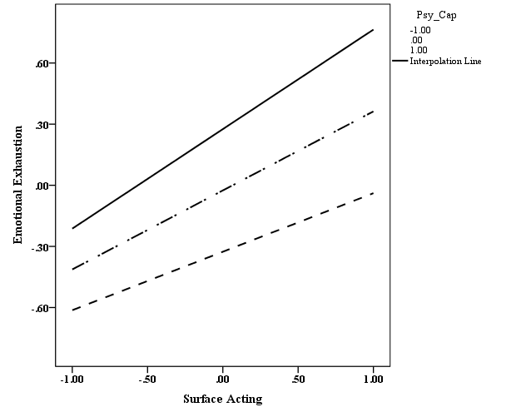

And here after final editing with a photo editor (Photoshop):

***Figure 1.*** Psychological capital as a moderator between surface acting and emotional exhaustion. All variables were standardized to mean 0, variance 1.

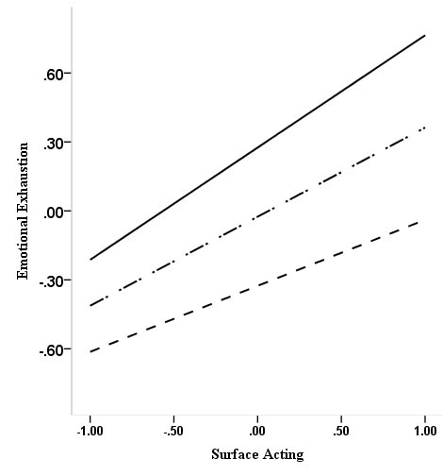

**Psychological Capital: ⎯ -1 ⋅ ⎯ ⋅ 0 - - - +1**

Journals discourage the use of color in graphs. Some charge authors an extra fee to publish graphs with colors. That said, it is easy to manipulate colors in SPSS. Here is an example:

process y=ZCatch/x=ZPriapam/w=ZKoleos/model=1/plot=1.

DATA LIST FREE/

ZPriapam ZKoleos ZCatch .

BEGIN DATA.

-.8859 -1.0208 -.2402

-.0222 -1.0208 -.0259

1.0740 -1.0208 .2460

-.8859 -.0185 -.3838

-.0222 -.0185 -.0156

1.0740 -.0185 .4517

-.8859 1.0350 -.5348

-.0222 1.0350 -.0048

1.0740 1.0350 .6678

END DATA.

GRAPH/SCATTERPLOT=

ZPriapam WITH ZCatch BY ZKoleos .

I pasted these data and the syntax, provided by Process, into a new syntax window. Then I edited the names, for example, changing ZPriapam to Standardized_Priapam. Then I ran the syntax, producing this plot:

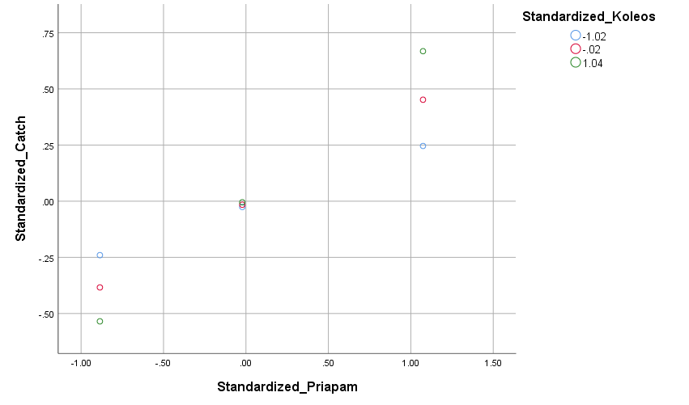

I opened the chart editor (double click on the chart) and hid the grid lines – Options, Hide Grid Lines – and produced the lines -- Elements, Interpolation Line. I selected one of the circles under “Standardized Koleos” and edited the size and color of the markers for it and then did the same for the other two. I should have been able to do the same for the lines, but SPSS just would not let me edit the type or color of the lines. It did allow me to make them thicker. At this point I just gave up.

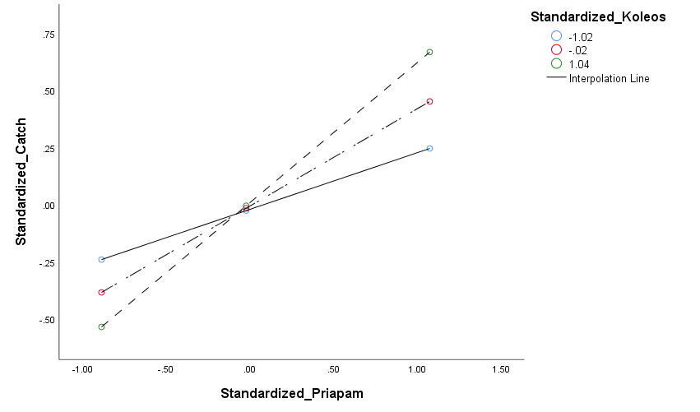

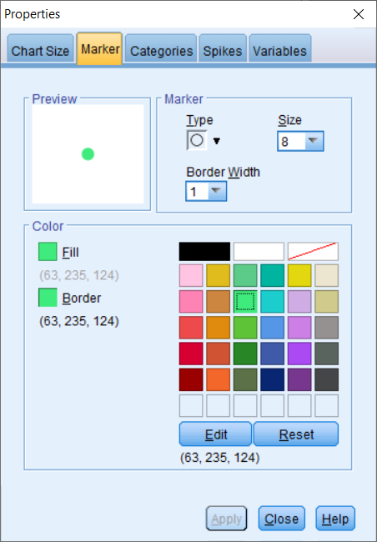

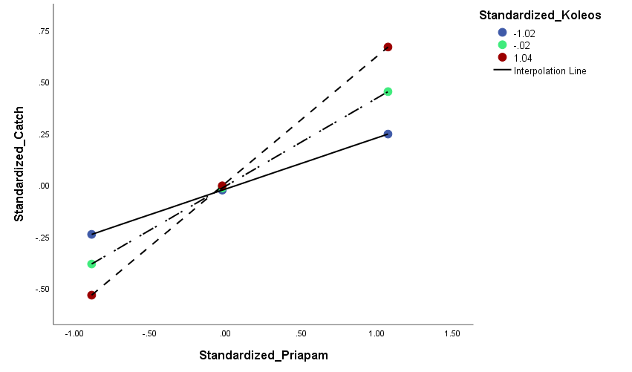

Finally, I recreated the plot but without the lines. Then I exported it to jpg and brought it into Microsoft Paint and drew the lines there.

